A.1
CREATE DATABASE SalesDB;
USE SalesDB;
CREATE TABLE OrderData (
OrderID INT PRIMARY KEY,
CustomerName VARCHAR(50) NOT NULL,
Email VARCHAR(80) NOT NULL,
City VARCHAR(30) NOT NULL,
ProductCategory VARCHAR(30) NOT NULL,
OrderDate DATE NOT NULL,
OrderAmount DECIMAL(10,2) NOT NULL,
OrderStatus VARCHAR(20) NOT NULL
);
INSERT INTO OrderData
(OrderID, CustomerName, Email, City, ProductCategory, OrderDate, OrderAmount, OrderStatus)
VALUES
(1, 'Rahul Sharma', 'rahul@gmail.com', 'Mumbai', 'Electronics', '2026-01-05', 55000.00,
'Delivered'),
(2, 'Priya Patil', 'priya@gmail.com', 'Pune', 'Furniture', '2026-01-08', 32000.00, 'Delivered'),
(3, 'Aman Verma', 'aman@gmail.com', 'Nashik', 'Clothing', '2026-01-12', 8500.00, 'Pending'),
(4, 'Sneha Joshi', 'sneha@gmail.com', 'Mumbai', 'Electronics', '2026-01-20', 72000.00, 'Delivered'),
(5, 'Karan Mehta', 'karan@gmail.com', 'Thane', 'Furniture', '2026-02-03', 28000.00, 'Cancelled'),
(6, 'Neha Shah', 'neha@gmail.com', 'Pune', 'Electronics', '2026-02-08', 48000.00, 'Delivered'),
(7, 'Rohan Desai', 'rohan@gmail.com', 'Mumbai', 'Clothing', '2026-02-15', 12000.00, 'Pending'),
(8, 'Meera Kulkarni', 'meera@gmail.com', 'Nashik', 'Furniture', '2026-02-22', 36000.00,
'Delivered'),
(9, 'Arjun Nair', 'arjun@gmail.com', 'Thane', 'Electronics', '2026-03-02', 64000.00, 'Shipped'),
(10, 'Divya More', 'divya@gmail.com', 'Mumbai', 'Furniture', '2026-03-07', 41000.00, 'Delivered'),
(11, 'Isha Singh', 'isha@gmail.com', 'Pune', 'Clothing', '2026-03-12', 15000.00, 'Shipped'),
(12, 'Om Jadhav', 'om@gmail.com', 'Mumbai', 'Electronics', '2026-03-18', 59000.00, 'Pending');
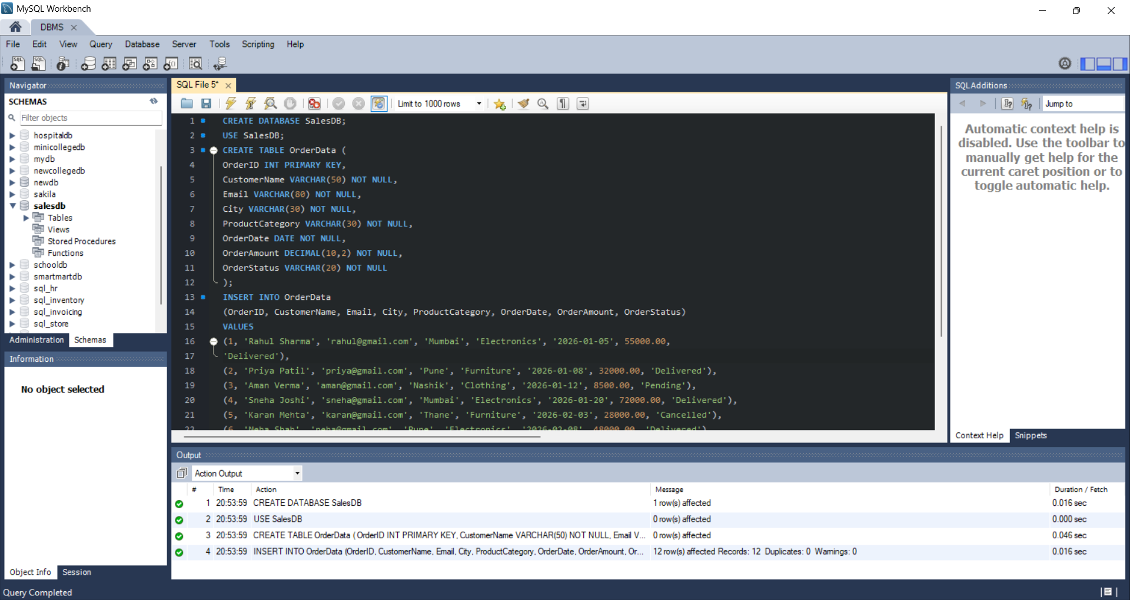

A.2
CREATE INDEX idx_city
ON OrderData(City);
CREATE UNIQUE INDEX idx_email
ON OrderData(Email);
CREATE INDEX idx_order_date
ON OrderData(OrderDate);
SHOW INDEX FROM OrderData;
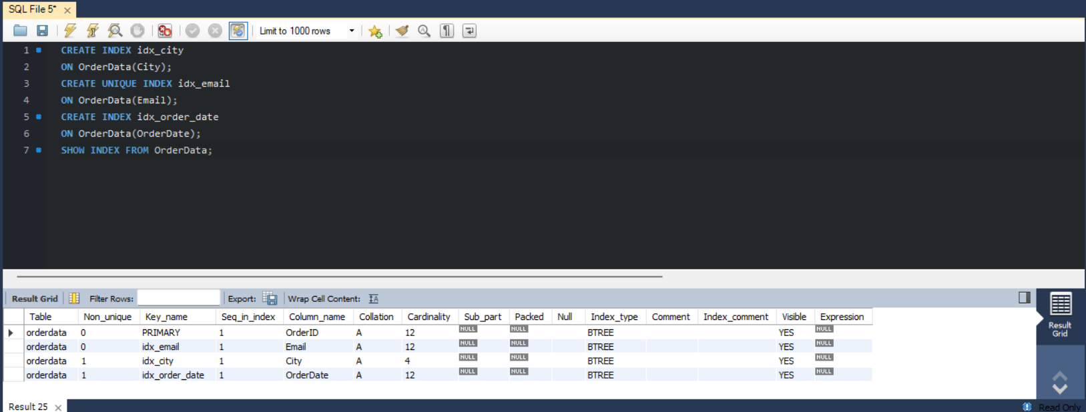

A.3
CREATE INDEX idx_city_order_date
ON OrderData(City, OrderDate);
SELECT OrderID, CustomerName, City, OrderDate, OrderAmount
FROM OrderData
WHERE City = 'Mumbai'
AND OrderDate BETWEEN '2026-01-01' AND '2026-03-31';
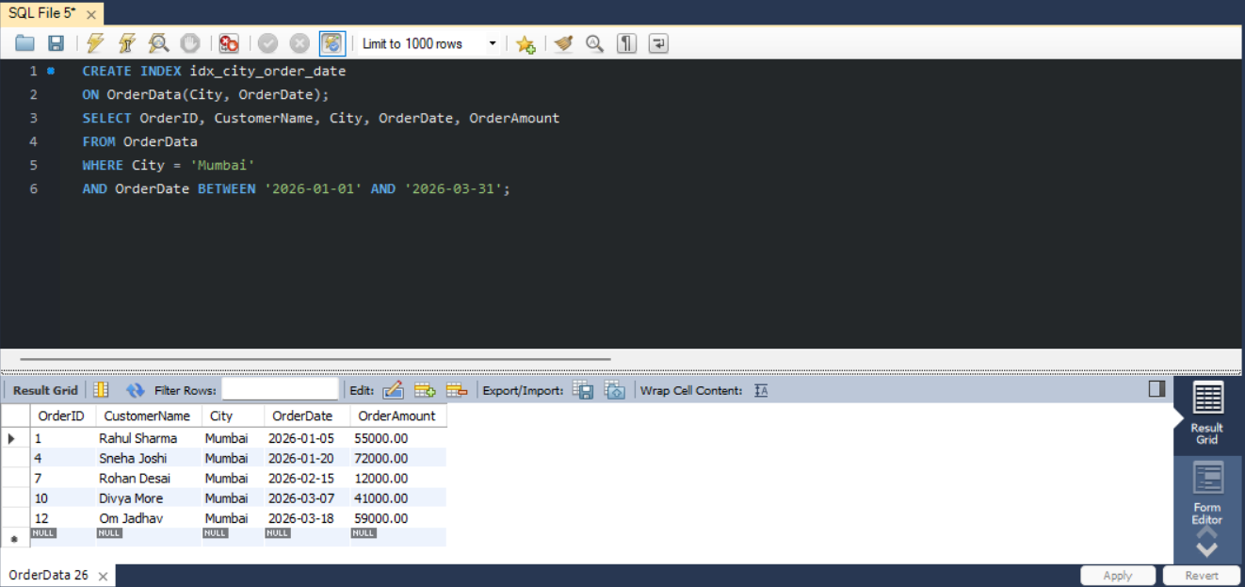

A.4
EXPLAIN
SELECT *
FROM OrderData
WHERE City = 'Mumbai';
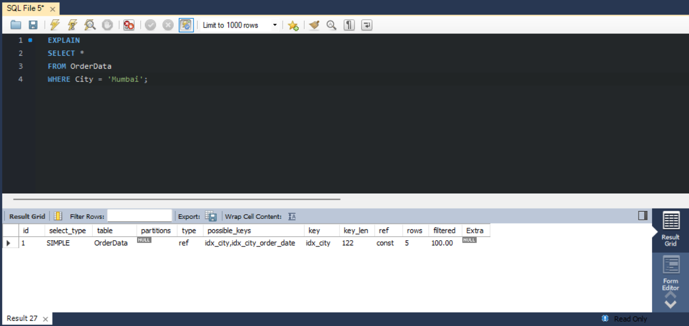
A.5
# Without Index
DROP INDEX idx_city ON OrderData;

EXPLAIN
SELECT *
FROM OrderData
WHERE City = 'Mumbai';
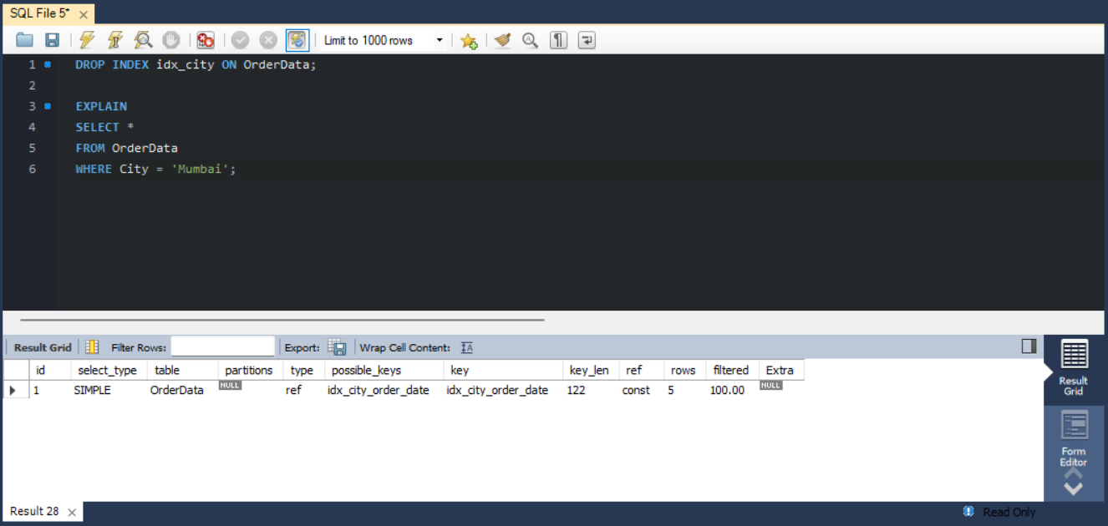

# With index
CREATE INDEX idx_city
ON OrderData(City);

EXPLAIN
SELECT *
FROM OrderData
WHERE City = 'Mumbai';
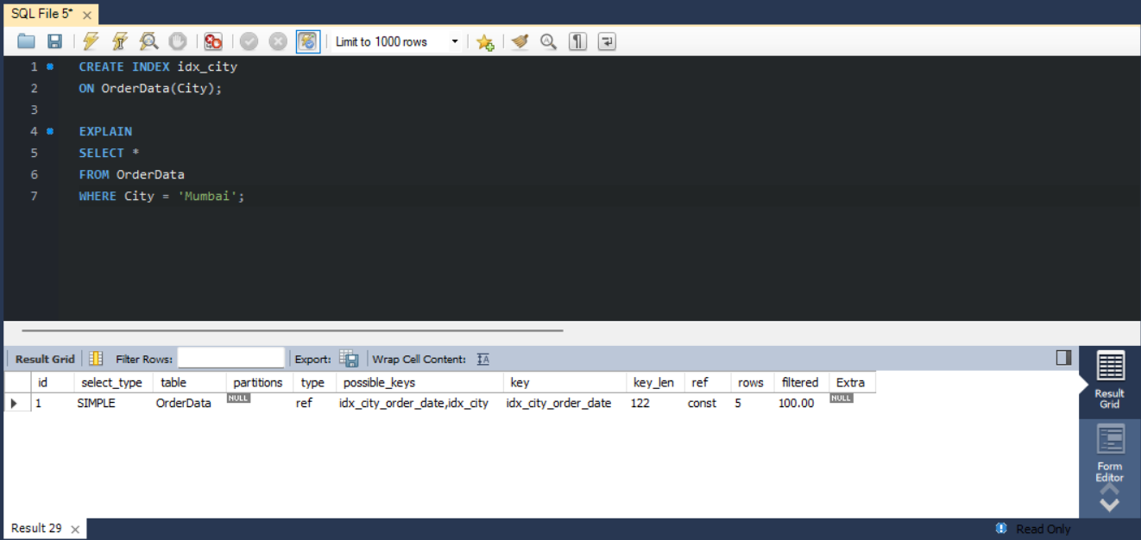

A.6
SELECT OrderID, CustomerName, OrderDate, OrderAmount
FROM OrderData
WHERE OrderDate >= '2026-01-01'
AND OrderDate < '2027-01-01';
